We got a ELF X86 file

Throw it into IDA

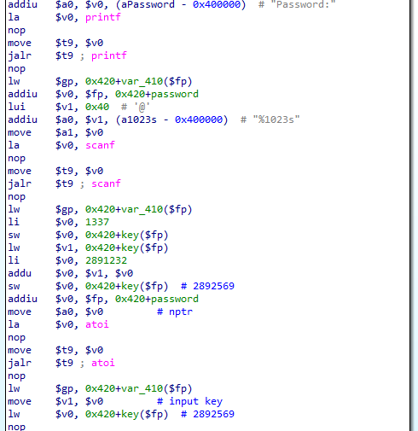

First, you can see, it require password which is get through scanf(“%1023s”)

Then it store 2891232 into variable key (location in memory)

Then it use atoi() to convert password into integer

store it in $v0

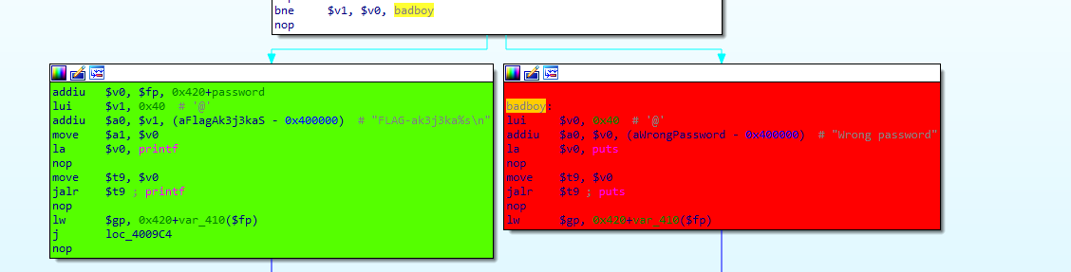

Finally, compare $v0 (password) with key(2891232)

if it not equal (bne) jump to badboy

else You get a flag which is concatenation from FLAG-ak3j3ka + password

Easy huh??

FLAG-ak3j3ka2891232